Certificate of Analysis

General properties:
Name： DSPE-PEG2000-RGD
Molecular Weight： 2000 Dalton
Cat.#： R-9958
Lot.#： RR0160672
Manufacture Date： 2016.07.06
Date of Analysis： 2016.07.06
Recommended Retest date： 2017.07.06
Stability： 12 months
Storage： -20°C in the dark

Structure

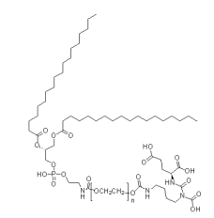

Items | Specification | Results
Appearance | White/ Off-white solid | White solid
¹H NMR | Identical to the structure | Identical to the structure
Foreign Material | None | None
Purity | ＞90% | 90%
Report Date: 2016.07.06

This product is for research use only, Not for human or animal use

