Certificate of Analysis

General properties:
Name： SH-PEG550-SH
Molecular Weight： 550 Dalton
Cat.#： SH-PEG-SH-550-1g
Lot.#： RS016003
Manufacture Date： 2016.06.03
Date of Analysis： 2016.06.03
Recommended Retest date： 2017.06.03
Stability： 12 months
Storage： -20°C in the dark

Structure
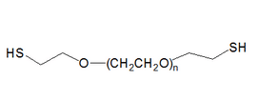

Items | Specification | Results
Appearance | Yellow liquid | Yellow liquid
¹H NMR | Identical to the structure | Identical to the structure
Foreign Material | None | None
Substitution | ＞90% | 90%
Report Date: 2016.06.03

This product is for research use only, Not for human or animal use

